SMART STUDY ENVIRONMENT ASSISTANT

Module Code - CMP4285
Team name - Placeholders

Table of content

Content | Page
Team Overview | 2
Product Description | 2-3
Alignment with SDG’s | 3
Technical implementation | 3-5
Customer | 5-6
Market | 6
Project planning | 6-7
Test planning | 7-8
Risk registers | 8-9
Visualisation | 9

1. Team overview
Team structure and role allocations:
Our team consists of 5 members studying computer science and related specialisations. Each member was assigned a primary responsibility while maintaining collaborative involvement throughout the project.

Role allocations:
Aisha mohamed - Research & Content Development Lead
Responsible for problem research, background analysis, report drafting, project sketches, and voiceover recordings for the final presentation.

Marharyta Prishchepa - Hardware & System Design Lead
Led the Tinkercad circuit design, implemented system coding, and supported component selection and cost estimation.

Simranjit Kaur - Documentation & Project Coordination Lead
Oversaw full documentation development, structured the innovation report, refined technical descriptions, and ensured consistency across all sections.

Parwinder Kaur - Presentation & Media Coordinator
Managed presentation preparation, visual materials, and video coordination to effectively communicate project outcomes.

Dilpreet Kaur - Testing & Quality Assurance Lead
Responsible for system validation, reviewing functional testing outcomes, supporting risk register updates, and contributing to system evaluation and improvement analysis.

Collaborative approach:
Although each member had a designated leadership area, all team members contributed to system testing, idea refinement, and documentation review. This collaborative approach ensured technical integration and shared understanding of the project’s objectives.

2.Product Description
In this modern study era, students study for extended time to complete their coursework, to research for their assignments, and to study for exams. In all of these things they forget to check the environmental conditions of their study space, and often forgets to take breaks.
To address this problem, our team came up with a solution, The Smart Study Environment Assistant. This device is integrated with a few key systems to help students manage their study space. This device is a compact Arduino- based system which monitors temperature and humidity of a room and provides structured reminders for hydration and study breaks.
This device integrates:
- Temperature monitoring
- Humidity monitoring
- Real-time LCD display
- LED status indicators
- Timer-based hydration reminders
- Break alerts
- User-adjustable settings vial push button
The goal is to create a simple, affordable, distraction-free desk assistant that improves focus and comfort.

3. Alignment with Sustainable Development Goals

SDG 4- Quality Education
Effective learning is inﬂuenced by more than just content and effort. The environment in
which students study plays a role in how well they concentrate and retain information.
By encouraging comfortable study conditions and structured habits, our system
supports improved focus and potentially better academic outcomes.
While it may seem like a small intervention, creating supportive learning environments
contributes to the broader goal of improving educational quality.

SDG-3- Good Health and Wellbeing
Hydration and environmental comfort are directly linked to physical and cognitive
wellbeing. Dehydration can reduce alertness, while uncomfortable study conditions
may increase fatigue. By reminding students to drink water and monitor their
surroundings, the system promotes healthier study behaviours.
In this way, our project supports both educational performance and overall wellbeing.

4. Technical implementation
Hardware components:
- Arduino UNO
- DHT11 Temperature & Humidity Sensor
- LCD 16x2 display
- Green and Yellow LED’s
- Buzzer
- Push buttons
- Breadboard & Jumper wires
- Power supply

Software:
- Arduino IDE
- Embedded C/C++
- Timer- based logic
- Conditional LED & Alert logic

Operational features:
- Continuous monitoring of temperature and humidity.
- Visual indication of environmental status.
- Break reminders.
- Hydration reminders alert.
- User-defined timing preferences.
- Simple, desk-based device

Circuit diagram:
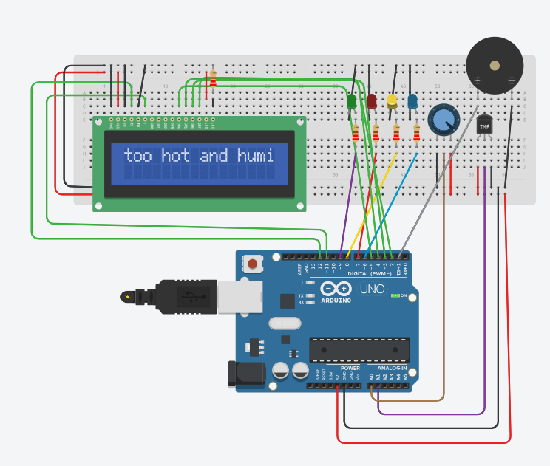

System implementation:
The Adriano uno is connected to temperature sensor and potentiometer to imitate humidity sensor, as tinkercad doesn't have one. The two LED lights, green and yellow, connect as well to indicate when the environment is ideal or not. When the temperature sensor and potentiometer give the numbers in range of indicated norm the green light lights up and the LED screen displays that the environment is ideal, if they give numbers that go above or under the screen displays why the environment is not ideal and the yellow light lights up.

Cost estimation:
Components | Prices
Arduino UNO | £11–£25
DHT11 Sensor | £5–£9
LCD 16x2 display | £9–£12
Buzzer | £3
LED Pack | £4–£12
Push Buttons | £7
Breadboard | £2–£15
Jumper Wires | £7–£14
Power Supply | £13

The total estimated cost of the prototype ranges between approximately £61 and £110 depending on the supplier and component quality. This demonstrates that the project is affordable and feasible for student-level development.

Unique Selling Points:
- All in one device
- Offline operations
- Affordable (< £110)
- Simple interface
- Designed specifically for students

5. Customers
Target Audience:
Primary customers:
- University students
- Students in shared spaces
- Library study users
Secondary Customers:
- Universities(bulk purchase for study spaces)
- Student housing providers
- Academic support centers

Customer need:
- Comfortable study environment
- Reduced distractions
- Better time management
- Hydration reminders
- Affordable solution
- Easy-to-use device
6. Market
Competitor Analysis:
Existing alternatives include:
- Study timer apps (Forest, Pomodoro apps)
- Smart thermometers
- Smart home assistants
- Standalone humidifiers or fans
Limitations of Competitors:
- Not integrated
- Require smartphones (distraction risk)
- No behavioural + environmental combination
- Higher cost
Our Advantage:
- Fully integrated desk solution
- No internet required
- Low cost
- Student-focused design

Market Opportunity:
- The UK university student population exceeds 2 million.
- Growing awareness of mental health and productivity.
- Universities investing in wellbeing tools.
- Affordable hardware allows bulk institutional purchase.

7. Project planning (Ghantt Chart)

Tasks | Week 1 | Week 2 | Week 3 | Week 4 | Week 5 | Week 6
Problem Research | —---------
Idea finalisation |  | —--------
Component Selection |  |  | —-------
Circuit design |  |  | —------- | —------- | —--------
Coding |  |  | —------- | —------- | —--------
Documentation |  |  | —------- | —------- | —--------
Submission |  |  |  |  |  | —--------

The Gantt chart demonstrates the timeline distribution of tasks throughout the project. Research and idea development were completed during the initial stage. Circuit design and coding were carried out in the middle phase. Documentation was developed continuously throughout the project to ensure accurate recording of progress. The final week focuses on review and submission preparation.

8. Test Planning

Test Case No. | Description | Input | Purpose | Expected Output | Actual Output
TC01 | Temperature Reading Accuracy | Room Temperature 18-22°C | Verify sensor functionality | LCD display accurate temperature
TC02 | High Temperature Detection | Temperature above 23°C | Ensure system detects uncomfortable heat | Yellow LED ON, warning displayed
TC03 | Optimal Temperature Range | Temperature  18-22°C | Confirm normal condition indication | Green LED ON
TC04 | Low Temperature Detection | Temperature below 18°C | Validate cold condition detection | Yellow LED ON, warning displayed
TC05 | Humidity Reading Accuracy | Humidity 40-60% | Validate DHT11 humidity accuracy | LCD displays correct humidity
TC06 | Low Humidity Alert | Humidity below 30% | Ensure dry air detection | Warning message displayed
TC07 | Study Timer Function | Timer set to 45 minutes | Verify break reminder system | Buzzer activates after 45 minutes
TC08 | Hydration Reminder | Timer set for hydration interval | Ensure hydration notification works | LCD message + buzzer alert
TC09 | Button Functionality | User presses setting button | Confirm user input works | Timer adjusts correctly
TC10 | LED Status Function | Environmentcchange | Validate visual indicator logic | Correct LED switches
TC11 | System Startup Test | Device powered ON | Verify boot process | LCD initializes, sensors start reading
TC12 | Continuous Operation Test | Device runs for 3+ hours | Ensure stability over time | No system crash or reset
TC13 | Power Supply Stability | Slight voltage variation | Validate power reliability | System remains operational
TC14 | Sensor Failure Simulation | Disconnect DHT11 | Check fault handling capability | Error message displayed

9. Risk Registers

Risk | Category | Likelihood | Impact | Mitigation Strategy
Sensor malfunction (DHT11 failure) | Technical | Medium | High | Test components early and keep a backup sensor if possible
Incorrect wiring or circuit error | Technical | Medium | High | Use Tinkercad simulation before physical assembly
Coding errors or logic bugs | Technical | Medium | Medium | Conduct regular testing and debugging
Power supply failure | Technical | Low | High | Test power connections and use reliable adapters
Delay in completing documentation | Time | Medium | High | Set internal deadlines before final submission
Time shortage before submission | Time | Medium | High | Prioritise core features and avoid unnecessary complexity
Team communication issues | Team | Low | High | Schedule regular updates and assign clear responsibilities
Unequal task contribution | Team | Medium | Medium | Clearly define roles and monitor progress
Budget limitations | Resource | Low | Medium | Use affordable and easily available components
Limited hardware availability | Resource | Low | Medium | Order components early and identify alternative suppliers

10. Visualization


